` **IBM – NAALAYATHIRAN**

**Research on Intelligent Vehicle Damage Assessment System Based on Computer Vision**

**LITERATURE SURVEY**

**TEAM MEMEBERS**

DANUSH HARI(TL)

DHAYABARAN

GOWTHAM

BARATH RAJ

BIBIN

**Research on Intelligent Vehicle Damage Assessment System Based on Computer Vision**

**Zhu Qianqian1, *, Guo Weiming1, Shen Ying2 and Zhao Zihao1**

1. China Automotive Technology & Research Center Co, Ltd., Automotive Data Center, Tianjin, China
2. China Banking and Insurance Information Technology Management Co, Ltd., Beijing, China

E-mail: *zhuqianqian91@sina.com

**Abstract.** At present, under the guidance of the new generation of information technology, the rapid accumulation of data, the continuous improvement of computing power, the continuous optimization of algorithm models, and the rapid rise of multi-scene applications have made profound changes in the development environment of artificial intelligence. In this paper, based on the demand of automobile insurance claims and intelligent transportation, combined with abundant basic data and advanced machine vision algorithm, an intelligent damage determination system of 'Artificial Intelligence + Vehicle Insurance' is constructed. This paper first introduces the functions of the intelligent damage assessment system. Secondly, it discusses the realization path of each functional module in detail, and finally puts forward the vision for the future.

# Introduction

According to August 22, 2018, 'China Banking and Insurance Regulatory Commission Office on the Monitoring of Small Claims Insurance Services in 2017' data show that: In 2017, 55.4113 million automobile insurance claims were settled normally. Among them, there are 40.128 million small-scale cases, accounting for 72.22%. The average insurance payment period for small-scale automobile insurance cases is 11.8 days, while the claim period for investigation, damage assessment and claim collection accounts for 9.94 days.

These data have triggered several reflections on small-scale cases: Firstly, for insurance companies, 72.22% of small cases require the presence of damage fixers, which leads to high cost of risk investigation, and the leakage problem in the process of damage fixing is difficult to control. Secondly, for the accident party, the long waiting time at the accident site, the slow payment process, the unreasonable fixed price and other issues, to a certain extent, reduce customer satisfaction with the insurance company. In addition, the potential dangers of traffic congestion and secondary accidents caused by small-scale cases also bring a great pressure to the traffic control department.

In the claims industry under the new generation of AI development plan, how can insurance companies move towards a new business model of 'Artificial Intelligence + Scene Application'? Deep convolutional neural networks [1, 2] have led to a series of breakthroughs for image classification [3]. With the development of deep learning [4], the process of computer vision has been greatly accelerated. Research on visual recognition is undergoing a transition from feature engineering to network engineering [5]. With the continuous innovation of AI algorithms and the increasing level of

Content from this work may be used under the terms of theCreativeCommonsAttribution 3.0 licence. Any further distribution of this work must maintain attribution to the author(s) and the title of the work, journal citation and DOI.

Published under licence by IOP Publishing Ltd

learning, open source deep learning framework and platform have become an important driving force for the development of AI. The improvement of hardware computing power ensures the rapid development of AI. At the same time, the massive data of the automobile insurance industry provides abundant raw materials for network model training. Therefore, we have enough data support and algorithm model to explore the new model of 'Artificial Intelligence + Vehicle Insurance' and build an intelligent damage determination system. Such a new model can not only effectively control the cost expenditure of automobile insurance companies, but also improve the owners' compensation experience. At the same time, it can effectively alleviate road traffic pressure and avoid traffic congestion and secondary accidents.

# The Functions of Intelligent Damage Assessment System

Intelligent damage determination system can be used to determine the appearance damage of vehicles in small cases. The system completes the whole process of survey and damage determination through four functions. They are:

1. Accident investigation: Photographs of target vehicles and multiple trio vehicles were taken and uploaded, intelligent recognition, information input, intelligent recognition and event finalization are completed in accident investigation.
2. Intelligent image damage assessment: image damage assessment is achieved by intelligent component recognition and intelligent damage recognition.
3. Damage result output: Damage results including maintenance scheme recommendation and maintenance price recommendation are automatically given according to damage recognition results.
4. Vehicle insurance anti-fraud: In the process of fixing the damage, the anti-fraud screening of vehicle insurance is completed by means of image fraud recognition and logical detection.

Intelligent damage assessment system can assist the damage locator in the front-end damage detection process. The operator only needs to take several photos to upload according to the requirements, and the system can automatically identify the damage degree of the damaged parts and components. The system in the back-end nuclear damage link can provide auxiliary nuclear damage and anti-fraud services. It can identify the cases of fixed-loss errors through the logical recognition of vehicle parts, image fraud recognition, fixed-loss logic recognition, etc. At the same time, it can also meet the demands of anti-fraud and leakage prevention.

At present, the intelligent damage assessment system can realize the appearance damage of passenger cars, including CAR, SUV, MPV and VAN. The applicable damage range covers all types of damage of vehicle exterior parts; the applicable environment range covers rain and snow environment, dark environment (vehicle can be seen by human eyes), strong light environment and other scenarios.

# The Realization Path of Intelligent Damage Assessment System

Intelligent damage determination system has four functional modules: accident investigation, image damage, result output and anti-fraud of automobile insurance. The implementation path is described in detail below.

## Accident Investigation

Accident investigation module includes the photography of certificates and vehicle photos, the intelligent recognition of certificate photos and the intelligent stereotyping work based on the basic information data of vehicle accessories.

*3.1.1. Take Photos.* The photographs taken in the accident investigation of intelligent damage determination system include driving license (front and side pages), driving license (front and side pages), person-car photograph, vehicle corner photograph and vehicle damage photograph. In order to apply the photograph of vehicle damage to the image damage based on artificial intelligence image recognition algorithm, some shooting requirements are put forward:

1. Using smartphones to shoot pictures with no less than 2 million pixels.
2. For the photography of vehicle damage, it is necessary to shoot the vehicle damage head-on so that the damage location is as far as possible in the center of the picture. The shooting distance is about 1 meter, and it is suitable to shoot clearly.
3. Multiple damage or cross-component vehicle appearance damage, if the damage distance is relatively close, then a photo can be taken, if the damage distance is relatively far, can not take a photo, then need to be taken separately.

In addition, the intellectualization of photography is also reflected in the following aspects: When taking photographs, it automatically identifies whether it is a document photo, a person-car photo, etc. If the photograph does not meet the requirements is not approved, it needs to be re-taken. At the same time, it is not mandatory to satisfy what angle of shooting can be taken, which is easy to operate and makes it easier for the damage fixer or other users to use.

*3.1.2. Intelligent ID Recognition.* For the photos of the uploaded driving license (front and side pages), driving license (front and side pages) and other documents, the intelligent damage determination system embedded OCR recognition technology. The VIN code, license plate number, engine number, driver's name and other information of the uploaded driving license and driver's license can be intelligently recognized and filled in.

At present, the embedded OCR technology can recognize Chinese characters, English upper and lower case letters, numbers and other information, and the recognition accuracy is 98.5%. Aiming at the problem of manual input for most fixed-loss products at mobile terminals, the embedding of OCR technology can not only save the time for the invalidation personnel to input the certificates without basic information, such as the three vehicles, but also effectively avoid the problems of input errors, which greatly improves the work efficiency.

*3.1.3. Intelligent Stereotyping and Fixing.* The advantages of intelligent loss determination system are also reflected in its abundant basic information data. Through VIN code, the basic information database of vehicles and accessories can be automatically linked to realize the output of specific vehicle information such as brand, vehicle system, vehicle type, and OE code of parts corresponding to vehicle type, so as to realize one-to-one correspondence between vehicles and accessories.

## Intelligent Image Damage Assessment

The core of intelligent damage fixing products is to determine which kind of damage happened to the exterior parts of the vehicle by image. The system has been experimented many times in the development of intelligent image damage algorithm. Finally, it divides the problem into three parts: the recognition of appearance parts by image, the recognition of damage parts by image, and the determination of damage parts by relative position relationship.

*3.2.1. Vehicle Appearance Component Recognition Algorithms.* According to the statistics of vulnerable parts in vehicle accidents, thirty-one vehicle exterior parts have been identified in this product. Each part is divided into front and back parts, regardless of left and right parts.

Aiming at the recognition of 31 vehicle appearance parts (regardless of left or right), the recognition algorithm for panoramic or local vehicles is realized, in the complex environment of rain and snow, too strong light or dark, by using the self-built data set of vehicle appearance parts and the depth learning target detection algorithm.The list of parts is shown in Table 1. The component recognition algorithm AP50 is 88.7%.

**Table 1.** Partial List of Vehicle Appearance Components.

|  |  |  |  |  |  |  |  |
| --- | --- | --- | --- | --- | --- | --- | --- |
| **Number** | **Component** | **Number** | **Component** | **Number** | **Component** | **Number** | **Component** |
| 1 | Front Bumper | 2 | Rear Bumper | 3 | Hood | 4 | Headlamp |

5

Roof Panel

6

Front Fender

7

Rear Fender

8

Front Door

In order to avoid overlapping of location areas after vehicle appearance parts detection, it is difficult to determine the location relationship of subsequent damage. The method of case segmentation is adopted, that is, the appearance of the image is recognized by the method of pixellevel object segmentation. As an extension of Faster R-CNN [6], Mask R-CNN [7] can achieve object segmentation. The effect of the recognition algorithm for vehicle appearance parts is shown in Figure 1.

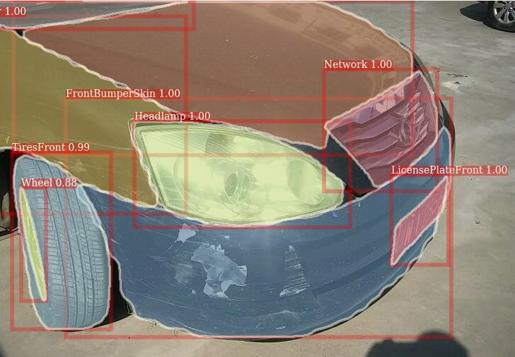

**Figure 1.** Effect Diagram of Vehicle Appearance Component Recognition Algorithm

*3.2.2. Damage Recognition Algorithms for Vehicle Appearance Components.* This product is aimed at six types of vehicle appearance damage, and also applies the deep learning target detection method. Through the self-built damage data set, it can recognize high-light pictures, low contrast pictures and multi-category mixed damage. The list of damage types is shown in Table 2. The damage recognition algorithm AP50 is 87.6%.

**Table 2.** Damage Type List of Vehicle Appearance Components.

|  |  |  |  |  |  |
| --- | --- | --- | --- | --- | --- |
| **Number** | **Damage Type** | **Number** | **Damage Type** | **Number** | **Damage Type** |
| 1 | Scrape | 2 | Scratch | 3 | Deformation |
| 4 | Cracking | 5 | Damage | 6 | SeriousDamage |

Damage data sets are labeled with rectangular frames. The effect of vehicle appearance damage recognition algorithm is shown in Figure 2.

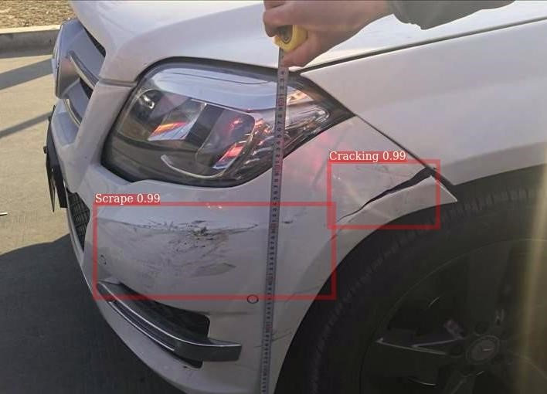

**Figure 2.** Effect Diagram of Vehicle Appearance Damage Recognition Algorithm

*3.2.3. An Algorithm for Locating Components and Damages.* By calculating the intersection relationship between the polygon identified by the algorithm of vehicle appearance components and the rectangular position identified by the algorithm of appearance damage, the appearance parts where the damage occurs are finally determined. At present, based on vehicle appearance component recognition algorithm, vehicle appearance damage recognition algorithm and image position determination algorithm, the comprehensive accuracy of image damage determination algorithm reaches 87.3%.

Input the original image, through image loss algorithm, it can realize the output of which component has what damage. For example, for the original image of the following Figure 3, the final output is: front bumper-scrape, front fender-scrape and deformation, as shown in the following Table 3.

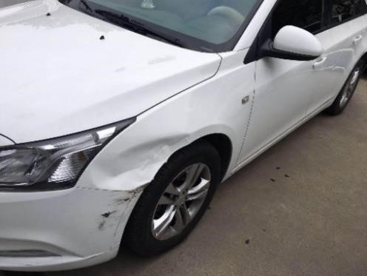

**Figure 3.** Input Image

**Table 3.** Damage Results List.

|  |  |
| --- | --- |
| **Component** | **Damage Type** |
| Front Bumper | Scrape |
| Front Bumper | Damage |

## Output of Loss Assessment Result

The output of fixed-loss results can not be separated from maintenance rules and repair logic. Among them, the maintenance rules are based on the experience of fixing damage and testing the appearance of components in the specific material damage needs to be maintained. The repair logic needs to formulate the damage inclusion relation logic, for example, if there are two damages in the same component, the maintenance scheme should adopt the scheme with higher maintenance level. Based on the maintenance rules and the repair logic, the repair knowledge base is established, the output of the maintenance plan is finally realized. The list of replacement knowledge is shown in Table 4. **Table 4.** Partial Replacement Knowledge List.

|  |  |  |  |
| --- | --- | --- | --- |
| **Component** | **Material** | **Damage Type** | **Maintenance Item** |
| Front Bumper | Plastic | Scrape | Repairing |
| Front Bumper | Plastic | Damage | Replacement |

## Vehicle Insurance Anti-Fraud

The automobile insurance fraud of intelligent damage determination system is mainly embodied in the following three aspects. It realizes the fraud recognition in the whole process of damage determination and can effectively control the cost expenditure of insurance companies.

1. Recognition of vehicle parts logical: It can identify whether there is logic between the model and the parts, and it is not allowed to choose the parts that are not logical when the damager automatically points out the damages. For example, the Corolla 2018 1.2T Intelligent Edition will warn and record when choosing the parking radar before and after parking.
2. Recognition of loss logic: After selecting assembly parts, the included parts will not be selected repeatedly.
3. Recognition of image fraud: It will automatically identify whether it is an accident photograph taken in real time, whether it is a PS photograph and so on.

## Brief Summary

The core advantages of the intelligent damage determination system based on computer vision are as follows: Intelligent image algorithm has high precision, the accuracy rate is 87.3%. It can assist all or part of the damage fixing personnel to complete the damage fixing work. The speed of survey and damage determination is fast, the time of survey and damage determination can be raised from 9.94 days to minute level. Intelligent wind control is rigorous, covering the whole process of fixed loss.

Intelligent damage determination system can effectively enhance the experience of automobile insurance companies, car owners and road traffic. It can effectively control the cost expenditure of automobile insurance company, reduce the cost of automobile insurance company investigation, realize the first spot investigation, accurately fix the loss and effectively control the cost of compensation. It can also improve the owners' claim experience and shorten the time for the owners to settle claims. At the same time, it can effectively alleviate road traffic pressure, avoid traffic congestion and secondary accidents, and improve the situation of insufficient police force at the grassroots level.

# Conclusion

In the future, we will continue to explore the innovation of insurance technology of 'AI + Vehicle Insurance'. We hope that we can use the power of intelligent damage determination system. On the one hand, the owner can take photos by one click to achieve rapid loss determination, price estimation and immediate compensation. On the other hand, it assists insurance companies to achieve rapid and accurate pricing in the process of fixing losses and claims. Finally, by combining the rapid compensation of accident vehicles to relieve traffic pressure, to avoid more serious personal and property losses caused by secondary accidents.

# References

1. LeCun, Y., Boser, B., Denker, J.S., Henderson, D., Howard, R.E., Hubbard, W., Jackel, L.D. Backpropagation applied to handwritten zip code recognition. Neural computation, 1989, pp. 541-551.
2. Krizhevsky, A., Sutskever, I., Hinton, G. Imagenet classification with deep convolutional neural networks. In *NIPS*, 2012, pp. 1097-1105.
3. Zeiler, M. D., Fergus, R. Visualizing and understanding convolutional neural networks. In *ECCV*, 2014, pp. 818-833.
4. LeCun, Y., Bengio, Y., Hinton, G. Deep learning. Nature, 2015(521), pp. 436-444.
5. Simonyan, K., Zisserman, A. Very deep convolutional networks for large-scale image recognition. In *ICLR*, 2015, pp. 1409.1556.
6. Shaoqing Ren, Kaiming He, Ross Girshick, Jian Sun. Faster R-CNN: Towards real-time object detection with region proposal networks. In *NIPS*, 2015, pp. 91-99.
7. Kaiming He, Georgia Gkioxari, Piotr Dollar, Ross Girshick. Mask R-CNN. In *ICCV*, 2017, pp. 2980-2988.